[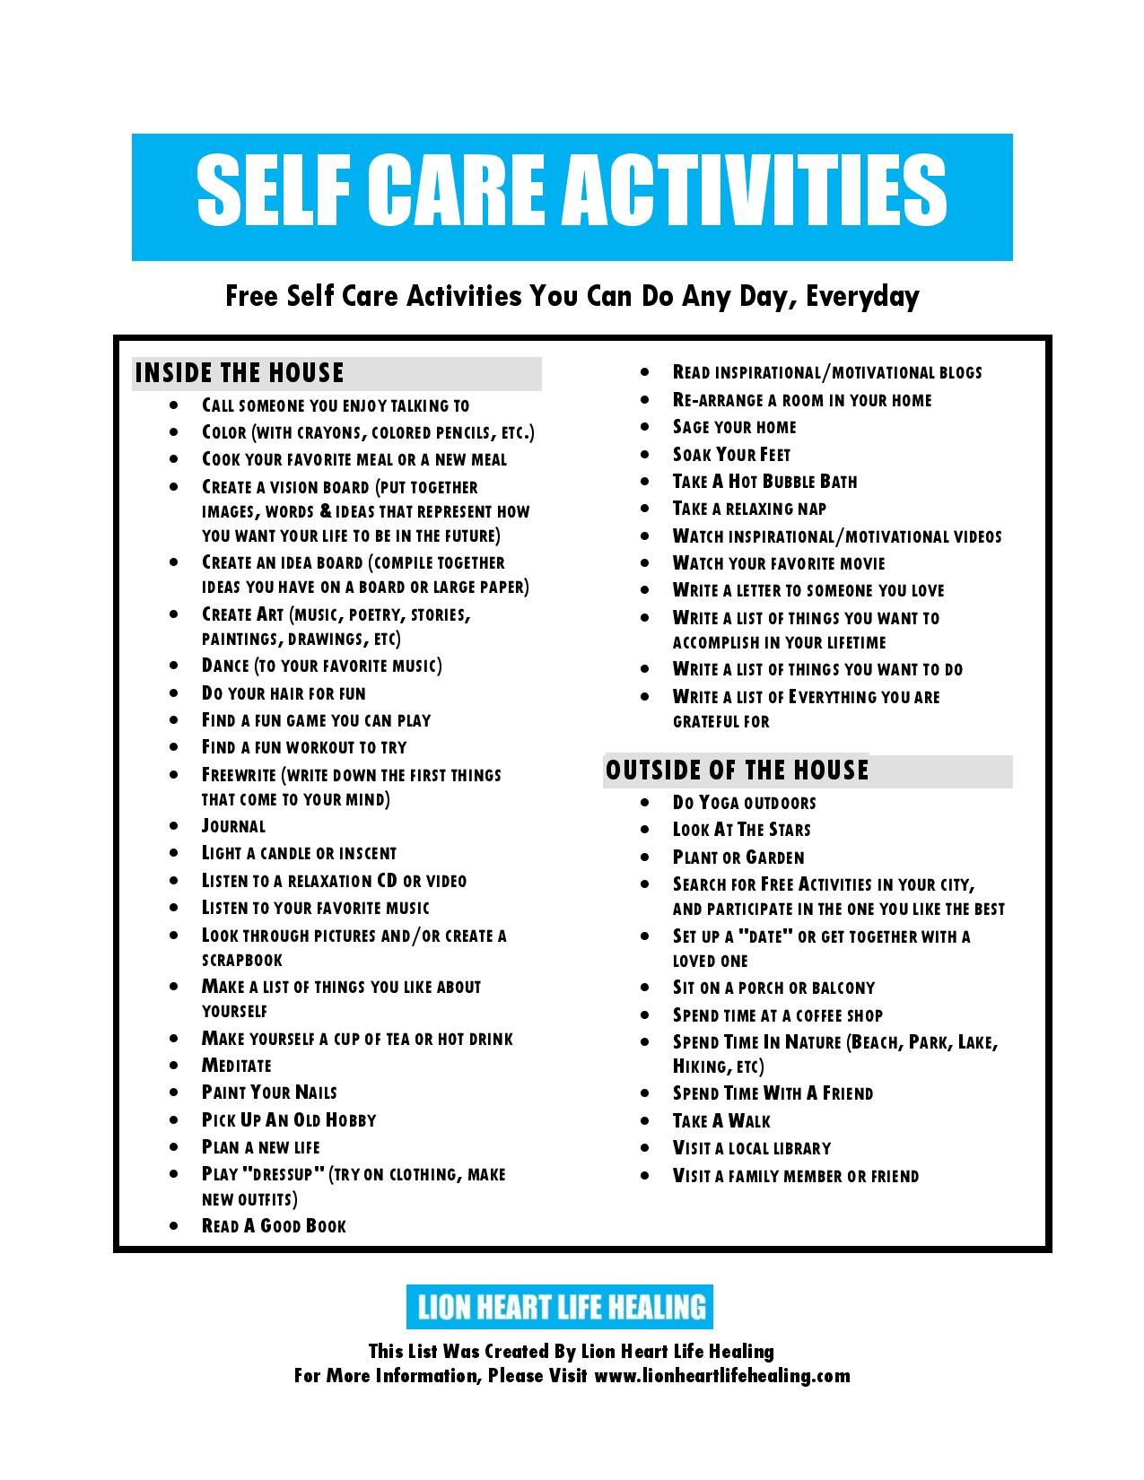](https://www.google.com/url?sa=i&url=https%3A%2F%2Fwww.pinterest.com%2Fpin%2F301459768799879840%2F&psig=AOvVaw0V9hVin4vbqjr6pJZxvp7Y&ust=1586982995973000&source=images&cd=vfe&ved=0CAIQjRxqFwoTCNji8b_i6OgCFQAAAAAdAAAAABAb)